Introduction
This official statistics release reports on children’s homes inspections that occurred between 1 April and 30 June 2012 under the Care Standards Act 2000. These statistics are based on provisional data and are subject to change.

Key findings

Inspections and outcomes of children’s homes full inspections

- The period 1 April to 30 June 2012 is the first quarter since the introduction of the revised Ofsted framework for inspection of children’s homes. Provisional statistics indicate there were 546 full inspections of children’s homes during this period. (Table 1)

- Of the 546 homes inspected, 47 (9%) were outstanding for their Overall effectiveness. 284 (52%) were good, 172 (32%) were adequate and 43 (8%) were inadequate. (Table 2)

- The percentage of homes receiving an outstanding Overall effectiveness grade has decreased from 18% in the equivalent quarter last year, while the percentage of homes receiving an inadequate Overall effectiveness grade has increased from 3% in the equivalent quarter last year. Ofsted use a proportional risk approach when scheduling children’s homes inspections, which makes a comparison between the first quarters of 2011 and 2012 the best comparator. (Table 2 + Chart 2)

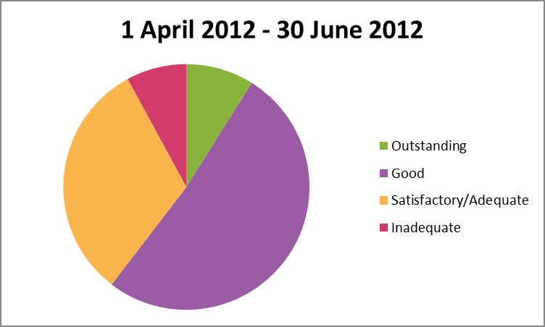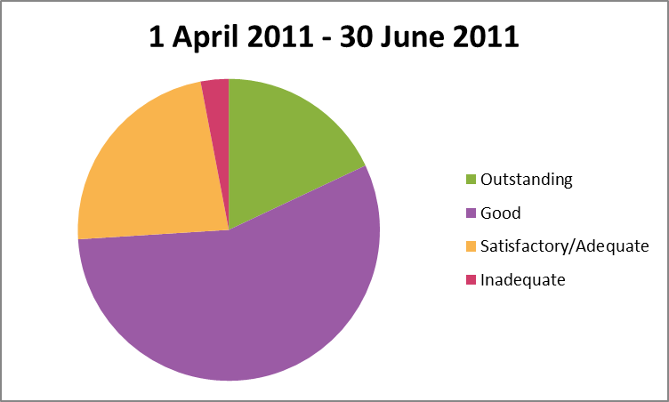

- The former Government Office Regions with the highest percentage of good or better Overall effectiveness grades, were the South East (73%) and West Midlands (70%). In contrast, fewer than half the homes in London (46%) received an Overall effectiveness grade of good or better (Map 1).

- There are marked variations at a local level in inspection outcomes. In areas, for example, where at least 10 children’s homes have been inspected during the quarter 92% of the homes located in Durham and 82% in Shropshire received a good or better Overall effectiveness grade, compared to 30% of the homes in Leeds and 48% in Somerset. These are inspections of all homes. not just those run by a local authority. (Table 4)

Sector data

- Of local authority-run homes, 58% (69), received a good or better Overall effectiveness grade, compared to 62% (252 homes) run by private or voluntary providers. (Maps 3 + 4)

- Seven percent of local authority run homes were judged outstanding for Overall effectiveness, compared to 19% in the equivalent quarter in 2011; and 8% were judged inadequate, compared to 3% previously. A similar change occurred for the other sectors: 9% were judged outstanding, compared to 18% in the equivalent quarter in 2011; and 8% judged inadequate, compared to 3%. (Charts 3 + 4)

- The sectoral picture, when grouped by former Government Office Regions, varies widely across the country. In the three regions in the North, as well as the South West and East of England, the percentage of homes receiving a good or better Overall effectiveness grade is higher among health authority, private and voluntary sector homes than local authority run homes. This is particularly evident in Yorkshire and the Humber, where 40% of the homes run by the local authorities were judged good or better, compared to 59% of other homes. In contrast, in the South East and London, local authority-run homes received a higher proportion of good or better grades. (Maps 3 + 4)

Interim inspections

- During the quarter there were far fewer interim inspections carried out on all types of children’s homes – 45 compared to 1,727 in the previous quarter. This is because under the new inspection framework which was introduced on 1 April 2011 children’s homes receive two inspections a year, of which the full inspection usually happens first. Of these 45 interim inspections, 11 (24%) made good progress and 28 (62%) made satisfactory progress. However, three (7%) made inadequate progress. Three (7%) did not receive an inspection outcome as children were not accommodated in the children’s home at the time of inspection. (Table 3d)

An amended inspection framework for children’s homes was introduced in April 2012. Details of the framework can be found at http://www.ofsted.gov.uk/resources/inspection-of-childrens-homes-for-inspections-1-april-2012.
See paragraph 5 in the following document ‘Conducting inspections of children’s homes from 1 April 2012’ which can be found at http://www.ofsted.gov.uk/resources/conducting-inspections-of-childrens-homes-for-inspections-1-april-2012.
Private and voluntary also includes those homes run by health authorities. Please refer to the glossary for more details on the different types of providers.
A new inspection framework for children’s homes was introduced in April 2011. Previously children’s homes had two inspections during the year that assessed the same outcomes. Under the new framework they are subject to a full (which usually happens first) and interim inspection each year. These inspections report on different inspection outcomes and are not directly comparable http://www.ofsted.gov.uk/resources/framework-for-inspection-of-childrens-homes-for-inspections-31-march-2012.

