Legacy cases – new data tool

Issue

We have been asked by a number of local authorities if we could look at their scorecard data separately for “new” cases as they consider that these demonstrate the improvements they have made to their adoption services. LAs must continue to progress older cases but the times of these older (or “legacy”) cases will naturally increase the overall averages in the scorecard indicators However, legacy cases are a circular issue, in that when you strip them out then the time taken to be adopted for the remaining children has an upper limit equivalent to the cut-off point for determining a legacy case. Similarly, an authority’s timeliness to adoption when including legacy cases will always be longer due to the nature of them being ‘legacy’ cases. Assessing how well an LA does once they’ve stripped out legacy cases can only be done by comparing to other LAs using the same definition, which would lead to a separate set of thresholds (rather than comparing to established thresholds) and could cause confusion.

We do not therefore intend to amend the scorecard measures, but we have developed a new data tool that will allow local authorities to compare the timeliness for children adopted and that of children still waiting. There are two variations on the tool, and in both cases local authorities can input their own data for the year to date as well as using the data published in the SSDA903 returns. The two bases which form the tool are attached, and the following notes explain how they can be used.

Feedback from a local authority that has kindly helped test this is:

- In the council’s opinion both options are useful but we are erring more to option two which helps to show the effect of Legacy cases on our scorecard and would be useful to demonstrate improvement and the impact of actions to improve are having which are slower to see reflected in the scorecard

- Option 1 is very straight forward and easy to use by all

- Option 2 follows on from option one but needs a bit more of an analytical background to understand or to explain to none technical colleagues (we have explained the methods to colleagues and keeping it simple can help them understand)

The measures

- To consider those children with a decision and calculate, as at 31 March, the average length of time since they entered care. This gives an idea of the time that the current group of children waiting to be placed for adoption have been waiting, and can be looked at in tandem with the A1 measure (i.e. if A1 is poor due to legacy cases being ‘cleared’, this extra measure should be improving, as it would show that the older cases have been cleared and the more recent cases are also being managed within reasonable timescales)

- To look at a box plot showing the middle 50% of cases in terms of timeliness from entry to care to a) placement for those adopted and b) 31 March for those waiting. Putting these alongside each other will give a sense of how the older and newer cases are being handled. Examples are given below. The box lines represent the lower quartile (25th percentile), median (50th percentile) and upper quartile (75th percentile):

    - If neither the older nor the newer are being handled quickly then legacy issues are unlikely to be playing a major role:
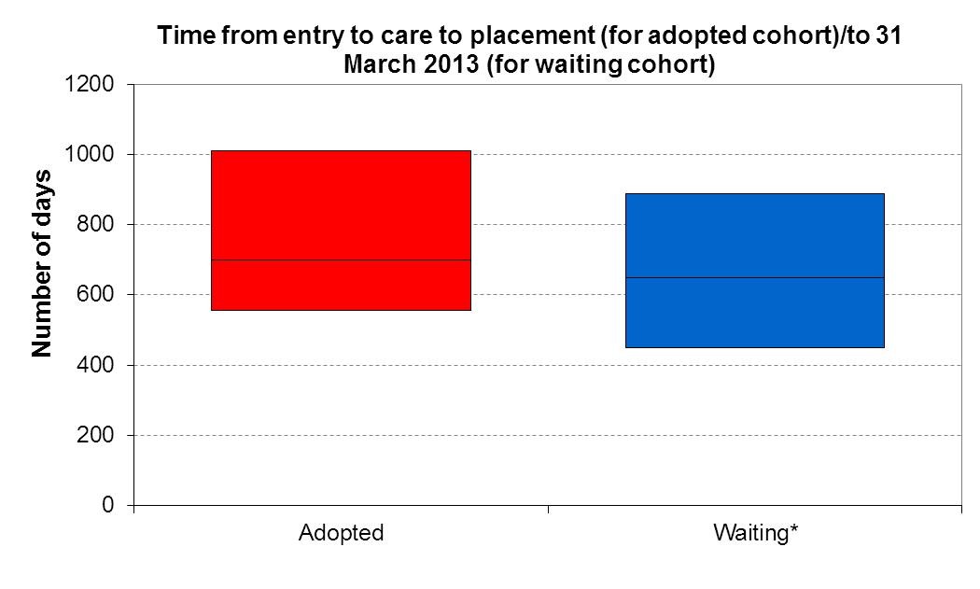
    - If the older and the newer cases are moving very quickly then the picture is good:
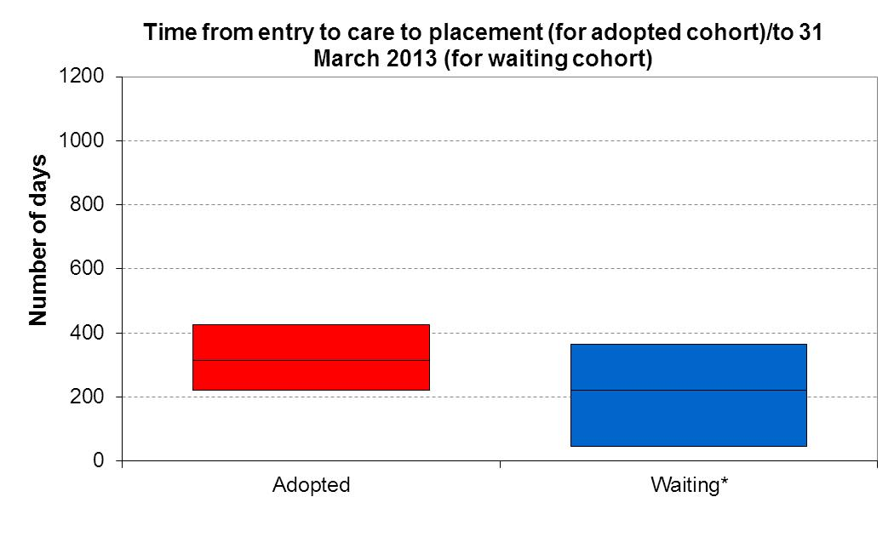
    - If the time for the adopted cohort is long (due to legacy cases) but those waiting have only been waiting a short time then it indicates an LA is doing well on the new cases:
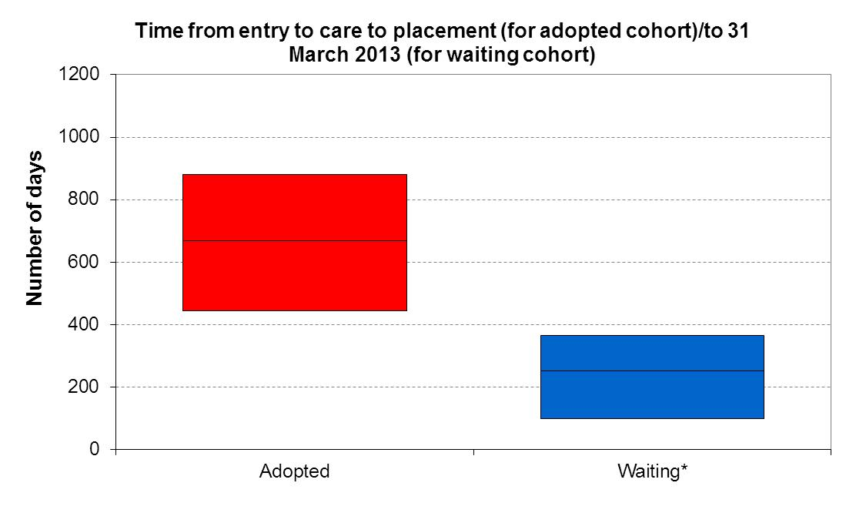
*Children with an ADM decision waiting to be placed for adoption (time from entry to care)

